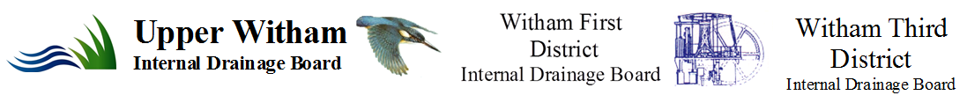
January 2014
Policy for the Scheduling of Watercourses

Introduction
The three Boards have regularly received requests to schedule watercourses and have traditionally considered each request individually. During discussion on recent requests it became apparent that a series of principles should be determined that could allow a consistency of approach to avoid any one Board being challenged.

Background
The Boards operate under the Land Drainage Act 1991 where Section 14 provides for Boards to:

- maintain existing works, that is to say, to cleanse, repair or otherwise maintain in a due state of efficiency any existing watercourse or drainage work;
- improve any existing works, that is to say, to deepen, widen, straighten or otherwise improve any existing watercourse or remove or alter mill dams, weirs or other obstructions to watercourses, or raise, widen or otherwise improve any existing drainage work; .
- construct new works, that is to say, to make any new watercourse or drainage work or erect any machinery or do any other act required for the drainage of any land. .
- carry out any drainage works for the benefit of their district or area in lands outside that district or area

Under common law, the responsibility for maintenance of watercourses rests with the riparian owner. The riparian owner also has certain benefits and responsibilities. As different owners have different priorities, needs and expectations as to the standard of maintenance required problems can result. Although a Riparian Owner has the right to receive flow of water in its natural state, to protect property from flooding, and to protect land from erosion, there is no requirement to improve the watercourse to accept flood flows or for other reasons.

The Boards have been established in an area classified as having a special drainage need to secure a high level of water level management to provide adequate levels of flood defence and land drainage. The Boards currently maintain a number of watercourses, balancing ponds, pumping stations and other structures. These assets can be classed as the critical infrastructure for the district. Boards are not responsible for canals and main rivers, but they have a supervisory duty in relation to all other watercourses in their districts.

Scheduling Criteria
Traditionally the Boards have considered each request to schedule a watercourse on its merit, without reference to specific criteria, based on a set of principles that have varied from case to case. The criteria listed below have been drawn up to reinforce and provide consistency in the decision making process. The following criteria could be used for the scheduling of watercourses, lagoons or any other asset:

 | The watercourse can be considered a primary drainage or flow route. | It is accepted a Board cannot maintain each and every watercourse in its district but it traditionally has considered that the primary flow routes should be maintained in good order to provide other watercourses an outlet.
 | The watercourse has more than one riparian owner/occupier, or that caters for more than one owner/occupier within its catchment. | This provides a safeguard that the Boards are not taking over riparian responsibilities from a single interest.
 | The watercourse has known drainage issues, where regular maintenance could resolve or ameliorate these. | There is a perceived need.
 | The watercourse lies within and/or serves a developed area or an environmentally sensitive area that could be impaired without regular maintenance. | It serves a flood defence or environmental purpose.
 | It is not maintained by another Flood Risk Management Authority. | All Flood Risk Management Authorities are considered competent organisations to define and undertake works on a watercourse. Authorities who can undertake works on a watercourse under the Land Drainage Act are:  - Environment Agency  - Unitary Authorities  - District Councils
 | Continuity with scheduled and/or designated watercourses downstream. | It is bad practice to leave riparian controlled reaches between scheduled ones.
 | New development that includes additional drainage infrastructure | Urbanised reaches are critical and require regular inspection and maintenance. Maintenance companies are considered unreliable insofar as experience suggests that they may not be in existence over the life of the development.

The above list is not exhaustive but provides a list of considerations to encourage consistency in decisions.

Watercourses that are subject to enforcement action or where a single “one-off” project is required to resolve the issue will not be considered for adoption on these criteria alone.

If an improvement scheme is required to be undertaken to make it an effective drainage route, then the improvement scheme must be beneficial to more than a single riparian owner or area owned by a single person, company or body.

The Boards will not schedule ‘isolated’ lengths of watercourses. The watercourse to be scheduled must discharge directly into a scheduled watercourse; a watercourse designated “Main River” under the terms of the Land Drainage Act, or other water body or sewer that has a recognised adopting authority which is responsible for its maintenance.

If scheduled, a watercourse requires good access for maintenance purposes. Any deficiencies will be corrected. It must be accepted by all riparian land owners/occupiers that the relevant Board’s Byelaws will be rigorously policed and enforced.

De-scheduling Criteria
Watercourses have been scheduled by the Boards in the past for a number of reasons. There may be a change in circumstances or a watercourse may no longer be considered as being appropriate for the Board to maintain. Examples of reasons for the de-scheduling are given below:

 | The watercourse can no longer be considered a primary drainage or flow route. | There has been a significant change within the catchment.
 | The watercourse has one riparian owner/occupier, or no longer caters for more than one owner/occupier within its catchment. | There has been an obvious reduction in beneficiaries.
 | It has been accepted by another Flood Risk Management Authority and placed on their maintenance schedule. | The responsibility has clearly transferred to another Flood Risk Management Authority.
 | All the riparian owner/occupiers or multiple owners within the catchment accept the de-scheduling and agree to accept their riparian responsibilities and rights | The responsibility has passed to a riparian owner/occupier.
 | The watercourse is found to be redundant for its original purpose and would not cause a drainage problem if it were abandoned by the Board.

The above list is not exhaustive but provides a list of considerations.

Financial Considerations
Work undertaken on watercourses that have been scheduled is normally paid for by the public purse. This means that the cost is met by drainage rates, local authority precept, Defra Grant in Aid, or other method by which the Board meets its revenue or capital budget.

Where the Board considers that a watercourse warrants scheduling but has issues in the level of maintenance that it has received or there is a need to improve the watercourse to provide an adequate level of service, then it would be expected that a condition of the scheduling would be that the riparian owners, or in the case of development, the developer, finances the improvement to the specification of the appropriate Board before the drain is scheduled. It is expected that the riparian owner will be responsible to make good any defects that occur within 12 months of the completion of the improvement works required by that Board, at no cost to that Board.

Where the need to schedule a watercourse follows development, the appropriate Board will, in any financial consideration of future maintenance costs, take into account any increased return expected to be gained from transferring land from a Drainage Hereditament into land from which that Board receives Special Levy. However, if the main beneficiary is land that lies either outside the drainage district or will not change its designation, then that Board would expect to receive a commuted sum, calculated in accordance with section 33 of the Land Drainage Act 1991 (Commutation of Obligations).

Should there be a requirement for a Board to become the landowner resulting from an application to schedule a watercourse, then the land will be transferred to that Board for a nominal sum with all related costs being met by the applicant.

- Review

This Policy should be reviewed as and when deemed necessary, but at least every 3 years.

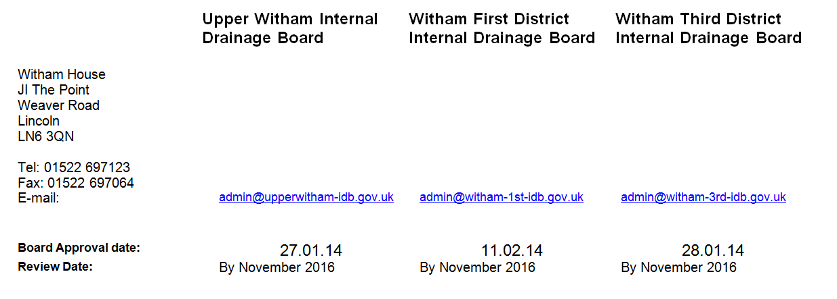

KJP

06.01.2014

JA-745-2013-POL

